**LAB EXERCISE – 1**

INSTALLING TERRAFORM ON WINDOWS

* Go to official site hashicorp.com and download the exe file for windows as per your requirement of 32 bit or 64 bit.

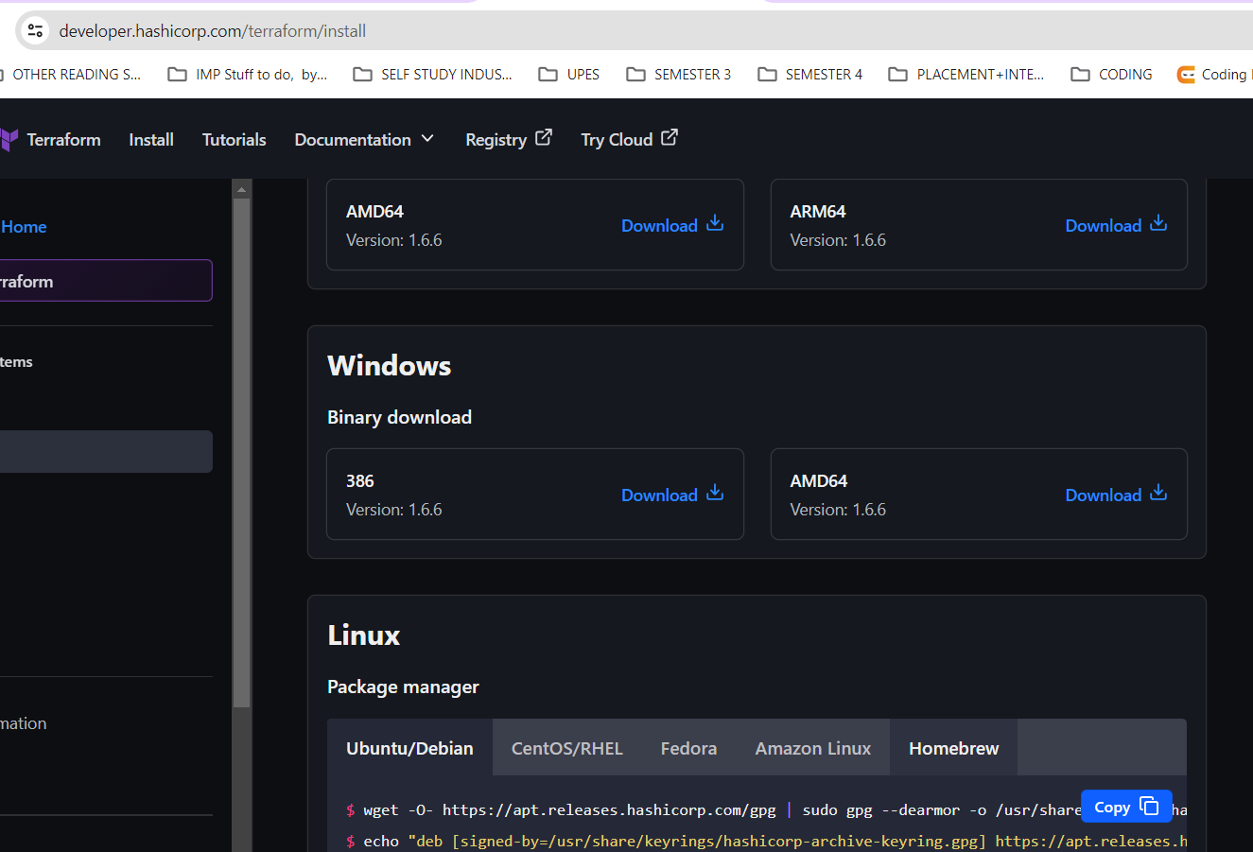

* Extract the files and in C drive make a folder named as terraform. Copy/paste the terraform.exe in it.

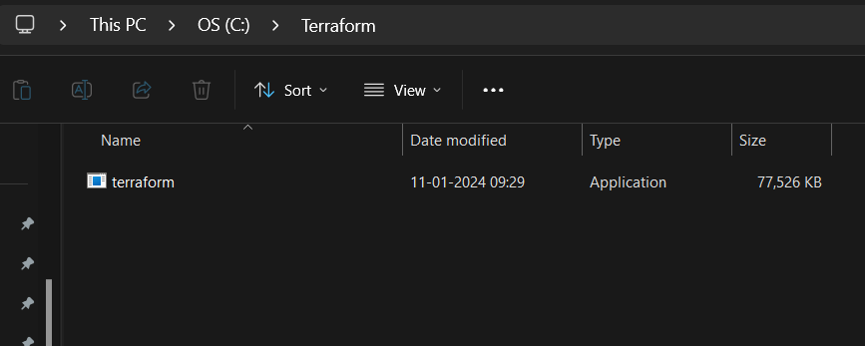

* Set the environment variable for terraform.

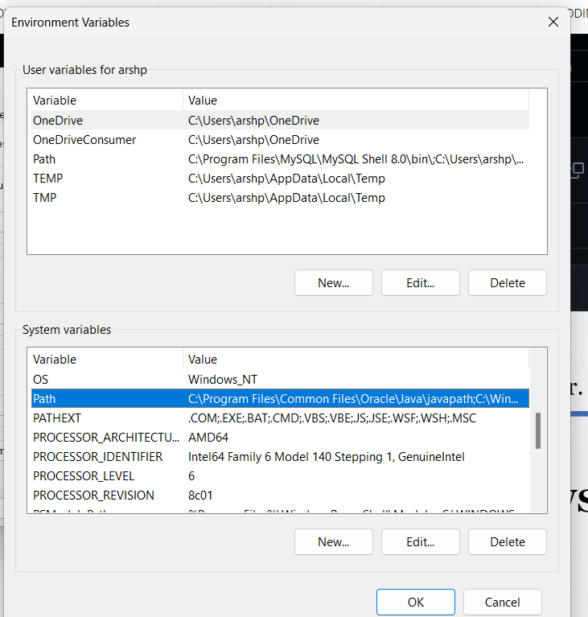

* On cmd run this command for the successful installation.

